Bioinformatics is an interdisciplinary field that combines biological and biochemical knowledge with mathematical and computer science methods in order to organize, analyze, and interpret experimental data. For instance, computers are used to compare the primary sequences of different proteins to identify key similarities and differences between those sequences that have arisen due to evolutionary selection processes. Computers can also be used to visualize the 3D structures of proteins based on data gathered through techniques like X-ray crystallography, NMR, and cryo-EM. Again, these 3D structures can be compared to identify the function of protein by comparing their shapes, or catalytic mechanisms can be discovered by observing ligands. While there are many purposes of bioinformatic analysis of data, we will focus on these three in lab today:
BLAST – used to identify an unknown protein by primary sequence
Custal Omega – used to align multiple protein sequences
PDBviewer mol* – used to visualize and assess proteins, and to investigate how specific noncovalent interactions connect to function

An important challenge when using bioinformatics is to remember the limitations present in each tool. Protein alignment software is only as good as the databases used to first form the data. Alignments can only be found for sequences present in the database. Furthermore, software is used to predict which amino acid changes are likely or unlikely. As more data is collected, these predictions will change. This is kind of like how the same web search will change over time. Depending on the database and how well designed the search algorithm is, a different result may occur. An Ecosia, Google, and Duckduckgo search will result in a different set of “hits” for the search “bioinformatics”. For structural data, again, the 3D structural prediction is only as accurate as the underlying experimental data. For instance, with X-ray crystallography, a protein is frozen in a single crystal structure. In solution, proteins are highly flexible and moving in many directions. The crystal is merely a snapshot of the many positions a protein can be in, and it may crystallize in a shape that rarely occurs functionally in nature. For instance, if you were to look at photos of myself, you would assume I am always smiling, but that may not be the case! Any crystal data needs to be validated experimentally using biochemical techniques.

Do the activity and Answer the questions written in italics.

Using BLAST to Identify an Unknown Protein by Primary Sequence

What is BLAST?
You probably perform online searches many times a day. Right in your own home, just saying words like “OK Google, who won the Nobel Prize in chemistry last year?” or “Alexa, what is the Henderson-Hasselbalch equation?” might trigger a series of complicated search algorithms to get you your answer. Similarly, you can learn about your protein by using web-based searches against known proteins in publicly accessible databases. Using these tools, you may be able to make predictions about your protein’s function based on what you know about its sequence and structure.

Closing the gap between a protein’s function, structure, and sequence through database searching is easiest if you already know the protein’s function – and if your protein is an enzyme, that means the reaction it catalyzes. In fact, for many proteins, the name of the enzyme is its function: hexokinase, for example, catalyzes the transfer of a phosphate group from ATP to a six-carbon sugar. If you wanted to know about the sequence of hexokinase, you would go to a database of protein sequences and enter “hexokinase” as a search term.

GenBank is such a database, maintained by the National Center for Biotechnology Information at the National Institutes of Health. It houses sequences of proteins and nucleic acids, submitted by researchers when they sequence proteins or DNA in their labs around the world. If you search GenBank for hexokinase, you will find not just one protein sequence, but tens of thousands, and at least that many DNA and RNA sequences if you search the nucleotide database. That’s the easy direction to search, because the names of those database sequences are all catalogued.

Searching by enzyme name is sort of like going to your local library to look up the text of Hamlet; all you have to do is look up where the volumes of Shakespeare plays are shelved and you’re all set. By contrast, it’s a lot harder if you have in mind a snippet of text, like “neither a borrower nor a lender be,” and you want to know where it comes from. Of course, nowadays you can just Google that and find out it is from Hamlet. But imagine there iss no Google and instead, you have to go through every line of every book in the library until you find the match. For protein (and nucleic acid) sequences, there is a tool called BLAST, or Basic Local Alignment Search Tool, that does exactly that, matching short sequences from a “query,” the sequence you’ve entered, against its libraries of data to identify hits to known “target” sequences¹.

The way BLAST does this is to divide your query text into short overlapping “words,” three letters at a time for amino acids. When hits to those short matches are found, BLAST extends them to look for longer matches. Even closely related proteins will likely have sequence differences, including variable amino acids, insertions, and gaps. BLAST scores these hits according to the sequence matches it finds: perfect amino acid matches score highest, conservative amino acid substitutions score favorably, and nonconservative substitutions score unfavorably; gaps are penalized according to size. The scoring is ranked according to a standard set of values, the most commonly used being BLOSUM64 (Blocks Substitution Matrix). In BLOSUM64, for example, an Arg in the query sequence matching to an Arg in a target sequence scores +5, an Arg in the query to a Lys in the target scores +2, and an Arg in the query where there is an Asp in the target scores –2.

While this is not as easy as searching by name, BLAST servers can usually complete a search based on a protein-sized query (hundreds of amino acids) in a few minutes or less. After a BLAST search is complete, it returns results as a table of color-coded bars and a listing of hits, followed by a display of aligned sequences, ranked by score. Along with the match score, BLAST gives the percent sequence identity and an E (“Expect”) value, which is the likelihood that the identified match would occur by a random assembly of amino acids. Better matches are reflected in higher scores and percent identities and, conversely, lower E values. If found, matches to defined protein superfamilies will also be displayed. In general, sequences identified as matches to a query in BLAST are considered evolutionary homologs, likely descended from a common ancestor, and highly similar sequences are likely to have similar structures. If they are enzymes, matches identified by BLAST may not necessarily share the same optimal substrate, but may have similar mechanisms of catalysis.

In the same way that everyday internet users do not need to understand the working details of Google, details of the BLAST algorithm go beyond the grasp of typical practicing biochemists.

However, just like a minimal appreciation for the way Google works can help you make good online decisions, a working knowledge of BLAST can help you to learn more about the biochemistry of a protein, gene, RNA, or genome and how it fits into the bigger biological universe

Orienting Yourself in the BLAST Results:
The Graphics Summary Panel will show you, first, a diagram representing matches between the protein X sequence you gave it (the “query”) and any conserved domains. If any of those domains belong to a grouping of proteins known as a superfamily, it will show you that, too. Below the conserved domains, it shows you a bar diagram of the best matches to individual sequences. This can give you a sense of whether there are many matching sequences to your query, or only a few. Red bars are the strongest matches.

The Descriptions Panel shows you the names of individual sequences that matched your query. Scanning this list can give you an idea of possible identity or function of your protein. Importantly, the descriptions panel also shows you statistics on the extent of each match, of which the most relevant is the E value. When you analyze your results, there are several metrics the BLAST search gives you to consider:
• The Total Score column gives the overall statistical similarity score from the scoring algorithm. It is important to understand that there is not a particular score that means the match is “good” or “similar enough”; the user must evaluate the results to determine which results are most useful to them.
• The Query Coverage is the percentage of the sequences that is aligned. In general, the larger this percentage the better the match, but this is not the only consideration. For example, for the Nudix hydrolases, there is a characteristic sequence that defines the superfamily (GX5EX7REUXEEXGU). Matching this sequence might be regarded as more important than having an overall high alignment percentage.
• The E Value score tells you how many matches you could expect by chance. A lower score indicates a more significant match; matches with E values that are greater than 10-10 are probably only marginally similar.
• The Identity Score describes the extent to which two sequences have the same residues at the same positions in an alignment. Again, a higher score usually indicates a better match, but this may not be the most important consideration.
• The final column (Accession) gives you the code for the protein in the database in which it was found.
• A homolog is a related protein or DNA sequence (one that matches by sequence alignment)
• An ortholog is a homolog that is found in different species (for instance, human alpha hemoglobin and mouse alpha hemoglobin)
• A paralog is a homolog that is found in the same species (for instance, human alpha hemoglobin, human beta hemoglobin, and human fetal hemoglobin)
• Finally, the Alignments panel shows you the actual sequence match-ups between your query and each match (or subject, labelled as “Sbjct”). If you were looking for matches to particular segments of your protein, this is where you would look for them.

Search Using BLAST:
First, use BLASTP to identify unknown protein X and related proteins from a database. BLAST stands for basic local alignment search tool. It is an algorithm for comparing a single protein sequence (the query) against all of the sequences in a chosen database. It finds the most similar proteins in that entire database. So, if you search for a protein sequence that matches the enzyme trypsin, it will return trypsin and related proteins (like chymotrypsin), but not unrelated proteins (like green fluorescent protein) even though all those proteins are present in the database. In a sense, it is like the “google” of protein alignments. You will be searching for the protein primary sequence below. This sequence is known as the “fasta” sequence. The line with the carat “>” Is a descriptive line. All subsequent lines are a sequence of amino acids, RNA, or DNA.

>Unknown protein X
MVLSDNDKTNVKATWSKVGDHASDYVAEALERMFFSFPTTKTYFPHFDLSHGSGQVKGHGKKVGEALTQA
VGHLDDLPSALSALSDLHAHKLRVDPVNFKLLSHCLLVTLSSHQPTEFTPEVHASLDKFLSNVSTVLTSK
YR

1) Go to https://blast.ncbi.nlm.nih.gov/ and choose protein BLAST

2) Paste the entire protein sequence (including the descriptive line) into the query window

3) Search the database “nr” for all known nonredundant protein samples and click “Blast” on the bottom left and WAIT.

4) Under the “Descriptions” tab, What is the protein you searched for? From what organism?
(hint: it has 100% “Query Cover” and 100% “Per. Ident”)

5) Is your protein more related to the ortholog from African elephant or the Indian elephant?
Support your answer using evidence from the descriptions tab

6) Click “hemoglobin subunit alpha [Elephas maximus indicus]” to go to the “alignments tab” comparing your query with this sequence. Which amino acids are different between your query and this elephant?
NOTATION EXAMPLE: If the third amino acid is switched from serine to threonine, write the change “S3T”

7) Click “hemoglobin subunit alpha [Loxodonta africana]” to go to the “alignments tab” comparing your query with this sequence. Which amino acids are different between your query and this elephant?
NOTATION EXAMPLE: If the 64 amino acid is switched from histidine to lysine, write the change “H64K”

8) Offer an evolutionary explanation for why Indian elephants and African elephants and your organism have different amino acid sequences. This can be a mechanistic explanation or an explanation based on evolutionary selection.

9) Under “other reports” above the descriptions tab, click “Distance Tree of Results”.
Explain in a sentence or two how this distance tree supports your claim in question 5.

10) Go back to protein BLAST. Repeat your search, but this time search against “Experimental Clustered nr Database”. Click on “Blast” and WAIT. Under the “clusters” tab, list three clusters of organisms that are found in your search.

11) Under “other reports” above the descriptions tab, click “Distance Tree of Results”. Using this tree, is your sequence more related to hemoglobin from even-toed ungulates or from insectivores? Explain in a sentence or two. Show a screenshot of your results.

12) Click on the “graphic summary” tab. Take time to explore this site. What specific hits and superfamilies are found in your query protein and in related proteins? What small molecule is shown to bind specific amino acids in your query protein?

Aligning Multiple Sequences

Rather than search one sequence against all known sequences, it is also very powerful to compare how a selection of related sequences is aligned. Two common multiple sequence alignment softwares are clustal omega and cobalt.

13) Go to the clustal omega web site https://www.ebi.ac.uk/Tools/msa/clustalo/
Scroll down to Multiple Sequence Alignment, and click on Clustal Omega

14) Enter the following FASTA protein sequences for beta hemoglobin

15) Enter a Title that you will remember, then click “Submit” and WAIT.

>human
MVHLTPEEKSAVTALWGKVNVDEVGGEALGRLLVVYPWTQRFFESFGDLSTPDAVMGNPKVKAHGKKVLG
AFSDGLAHLDNLKGTFATLSELHCDKLHVDPENFRLLGNVLVCVLAHHFGKEFTPPVQAAYQKVVAGVAN
ALAHKYH

>baboon
MVHLTPEEKNAVTALWGKVNVDEVGGEALGRLLVVYPWTQRFFDSFGDLSSPAAVMGNPKVKAHGKKVLG
AFSDGLNHLDNLKGTFAQLSELHCDKLHVDPENFKLLGNVLVCVLAHHFGKEFTPQVQAAYQKVVAGVAN
ALAHKYH

>human_sickle_cell
MVHLTPVEKSAVTALWGKVNVDEVGGEALGRLLVVYPWTQRFFESFGDLSTPDAVMGNPKVKAHGKKVLG
AFSDGLAHLDNLKGTFATLSELHCDKLHVDPENFRLLGNVLVCVLAHHFGKEFTPPVQAAYQKVVAGVAS
ALAHKYH

16) Click on “Show” below Alignment with colours to show the different “flavours” of amino acids.
• Red amino acids are small and hydrophobic
• Blue amino acids are acidic. Magenta amino acids are basic
• Green amino acids are hydroxyl, sulfhydryl, amine, or glycine
• Other amino acids are grey.

17) Make a note of the consensus markings at the bottom of the alignment.
• Identical amino acids across sequences are marked with an asterisk (*). For instance, if all three proteins have an Isoleucine, then an asterisk will appear below.
• Highly similar amino acids are marked with a colon (:). For instance, if one sequence has a serine but the others have a threonine, then that alignment will be marked with a colon because both amino acids contain an alcohol group.
• Slightly similar amino acids will be marked with a period (.) For instance, an alignment that matches a serine and asparagine will be marked with a period because they are both polar.
• Dissimilar alignments have a space ( ).

18) Paste a photo of your alignment

19) List the highly dissimilar amino acid differences between human and baboon beta hemoglobin.
Write the human amino acid, the position number, then the baboon amino acid.

20) List the highly dissimilar amino acid differences between human and human (sickle cell) beta hemoglobin
Write the human amino acid, the position number, then the human (sickle cell) amino acid.

21) Why does the conservation of glutamate at position 7 between humans and baboons lend credence to the claim that the mutation of glutamate 7 to valine affects sickle cell anemia?

Visualizing hemoglobin using mol*

The 3D structure of a protein enables its function. For instance, for an enzyme, the 3D structure makes “pockets” for reactants to come together and orients catalytic amino acid residues in close proximity to the reactants. More specifically, the protease TEV breaks apart a peptide bond at the carboxy side of Glutamine (Q) in the sequence ENLYFQ\S because it contains a binding pocket that can fit the amino acid sequence ENLYFQ\S. That binding pocket contains TEV’s catalytic amino acids aspartate, histidine, and serine (see figure below).

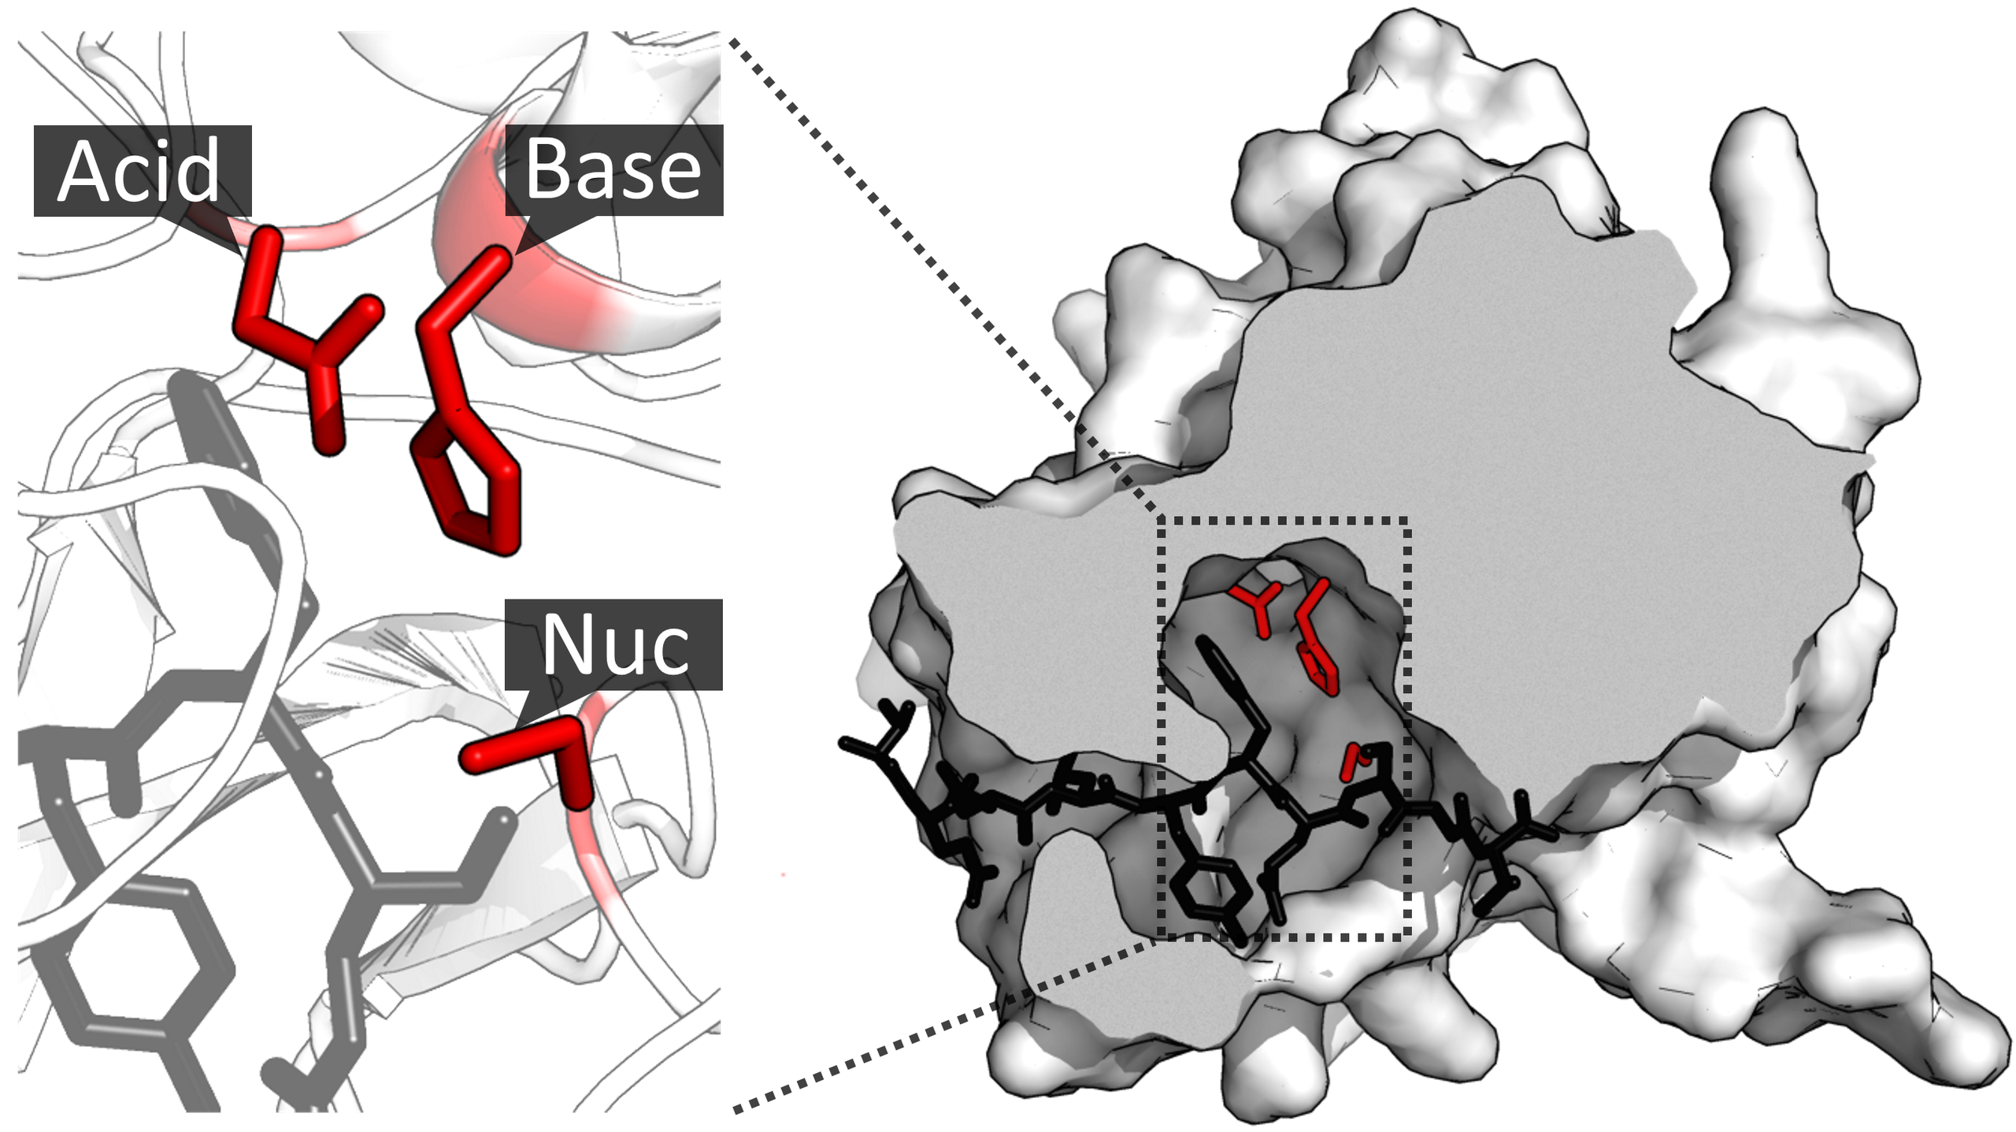

Figure 1. The enzyme TEV protease[a] contains an example of a catalytic triad of residues (red) in its active site. The triad consists of an aspartate (acid), histidine (base) and serine (nucleophile). The substrate (black) is bound by the binding site to orient it next to the triad. (PDB: 1LVM; https://en.wikipedia.org/wiki/Catalytic_triad)

3D structures of proteins are discovered using experimental techniques including x-ray crystallography, NMR, and cryo-EM. The data from these techniques are used to generate 3D structural models of proteins. More, and more, computers are being used to predict the 3D structures. Indeed, google software called alphafold has predicted the structure of every protein in the known universe. That’s millions of structures predicted compared to a few hundred thousand protein structures determined experimentally.

It’s important to note that structural prediction and experimental structural determination are highly complementary. The structural prediction software uses machine learning to learn from the known, published structures and make predictions. So, as more structures are experimentally solved, structural prediction will become more accurate. Furthermore, structural prediction and experimental data can be used together on the same protein complex. Alphafold and cryo-EM were used together to recently solve the structure of the nuclear pore complex.

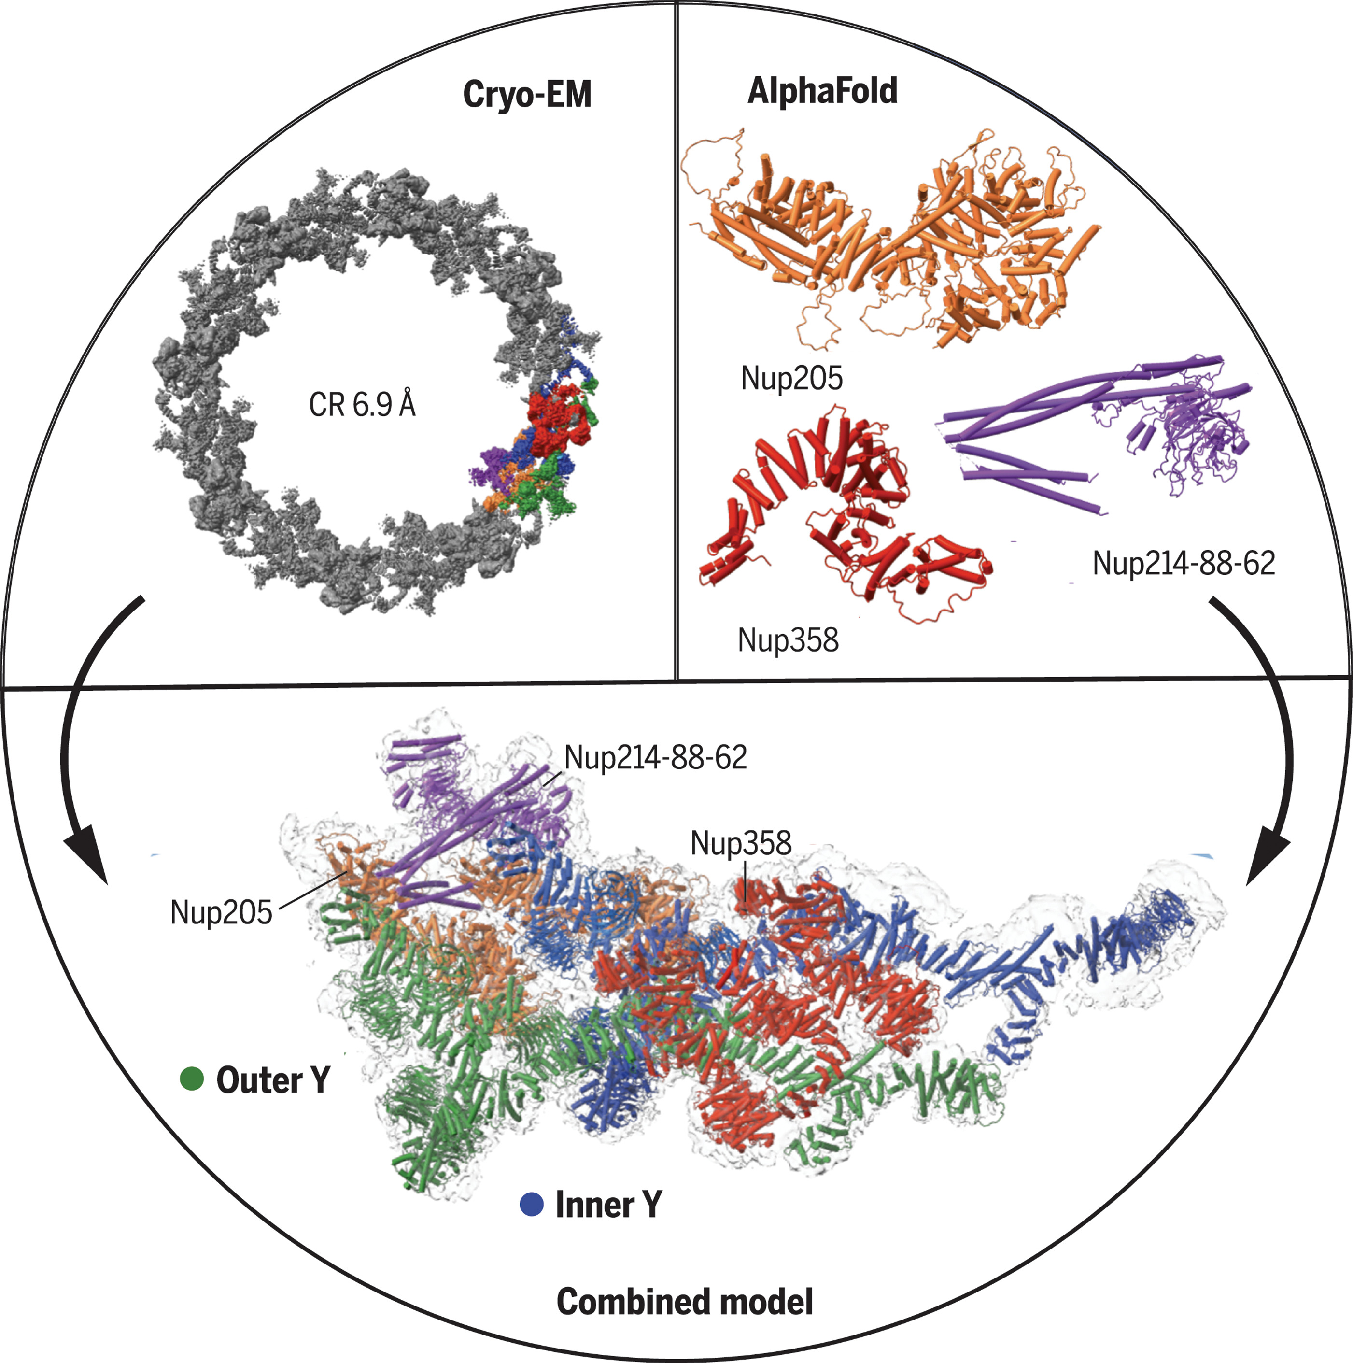

Figure 2. Cryo-EM structure of the cytoplasmatic ring of the nuclear pore complex from X. laevis. The 6.9 Å map was generated with single-particle cryo-EM, and the model was built with AlphaFold structure prediction. The secondary structural elements guided EM map fitting, resulting in an almost complete model of the complex. The approach allowed the identification of five copies of Nup358 and a second copy of the trimeric Nup214-Nup88-Nup62 complex. (reproduced from: https://www.science.org/doi/10.1126/science.abm9326)

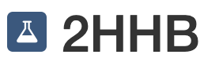
If experimentally determined structures were generated using public funding (NSF, NIH, HHMI, EBI, and others), they are deposited into the Research Collaboratory for Structural informatics (RCSB) protein data bank (PDB), given a unique PDB ID, and labeled with an Erlenmeyer flask (e.g. ). Today we will explore the following protein structures:

PDB ID | Description
2hhb | The structure of human deoxyhemoglobin
1hho | The structure of human oxyhemoglobin
2hco | The structure of human hemoglobin bound to carbon monoxide
1hbs | The structure of human hemoglobin S (sickle cell anemia hemoglobin)

You will complete the following tasks:
• First, you will practice manipulating and visualizing hemoglobin S
• Then you will depict and measure the distance between a histidine amino acid and the iron of heme when heme is bound to nothing, to oxygen, or to carbon monoxide.
• Finally, you will answer questions about each.

22) Watch this video created by the protein databank that describes how to navigate around a structure, how to change visual styles, and how to make specific selections: https://www.youtube.com/watch?v=EdgmALgbJpM

23) Go to the pdb web site: https://www.rcsb.org/

24) Search for 1hbs (you can also simply google 1hbs pdb)

25) This structure is a quaternary structure. Four proteins have come together to make hemoglobin (two alpha globin proteins and two beta globin proteins). You will see all four proteins (also called “chains”) in your 3D view. Throughout this activity, you can focus on specific “chains” at the primary, secondary, tertiary, or quaternary structure level.

26) Click on the “Structure Tab”. This will bring you to a 3D view of the protein.




27) Click the “Expanded View Port” button in the viewport control panel

28) Change how the alpha hemoglobin subunits are visualized


a) Click “selection mode” in the viewport control panel

b) A selection mode control panel appears in the top of the viewport
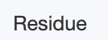
c) Change from “residue” selection to “chain”

d) Move your mouse over different protein subunits. In the bottom right corner, there’s a description of the subunits. When your mouse is hovering over an alpha subunit, select it! In the depiction below, my mouse is hovering over an alpha subunit labeled chain “C”…

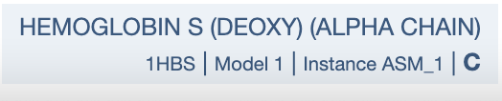

e) In hemoglobin molecules, the alpha chains are kiddy corner from one another.\
Rotate the hemoglobin molecule and select the second alpha chain.

f) With both alpha chains selected, click the “Create Component” cube in the selection mode panel.

g) Under “Options” select “Label” and label this component “alpha chains”

h) Click “+ Create Component”

i) Under the main control panel on the right, the “alpha chains” selection should appear below “polymer” and “ligand”.

j) Click the “…” next to “alpha chains” and select “add representation” then “molecular surface”


k) Change the color of the molecular surface by clicking “molecular surface representation” click the “…” next to “Color Theme”. Click the bookmark and then click “Qualitative” and choose a new color theme.

l) Take a picture of your current representation and paste it below. In this case paste a screenshot rather than a formal picture. Show your control panel settings, too.

29) Next, let’s find the mutant amino acid in hemoglobin S, and depict it differently

a) First, open the selection panel, and return selection mode back to “residue” from “chain”

b) Next, draw your attention to the sequence panel above the viewport

c) Make sure you’re viewing the correct primary sequence. Under “sequence of” select the correct chain. The beta chain contains the sickle cell mutation.

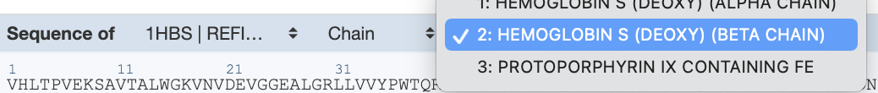

d) Find the V6E mutation. Wild type beta hemoglobin reads “MVHLTPEEKS”. This mutant will read “MVHLTPVEKS”. Click on the mutant valine residue in the sequence panel.

e) The viewport should zoom into the mutant valine residue.

f) Make a note, are you looking at the mutant valine on chain “B” or Chain “D”? The description box in the bottom right corner will tell you when you mouse over the valine molecule.

g) Use the “cube” symbol to create a new component. Label that component as “mutant valine Chain B” or “mutant valine Chain A”

h) Click on the “…” for the new component in the main control panel

i) Click “add representation” ⟶ “label”

j) Click “add representation” ⟶ “ball and stick”

k) Click on the “ball and stick” representation you created and under “size theme” increase the size to make the ball and stick model more visible (say, approximately 3x bigger).

l) Once you have labeled the mutant valine on one beta chain, repeat for the other chain.

m) NOTE: If your selection is focused and you cannot see the entire hemoglobin molecule, you will need to remove the focus from the selection. Above the “measurements” tab in the control panel, there is a focused molecule. Mine is Val 6 B.

n) Click the “X” to remove this focus

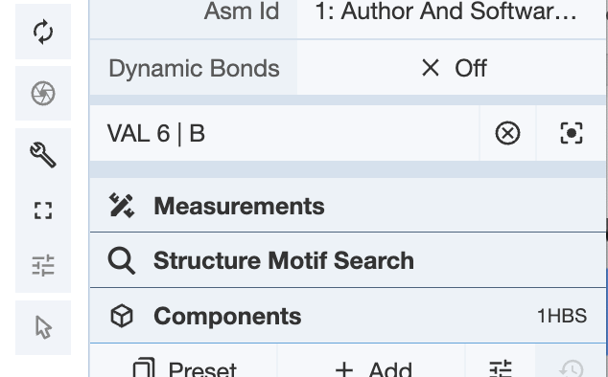

o) Submit a proper picture of the entire molecule with your mutant valines prominently displayed.

p) In two or three sentences, explain how the E6V mutation might cause aggregation of hemoglobin molecules, and thus sickle cell anemia.

Now that we’ve visualized the important E6V mutation that causes sickle cell disease, let’s focus on how hemoglobin functions normally. Notice below how the entire structure of hemoglobin changes shape in response to oxygen binding. The changing shape of hemoglobin lets the second, third, and fourth oxygen bind more easily to hemoglobin than the first oxygen.

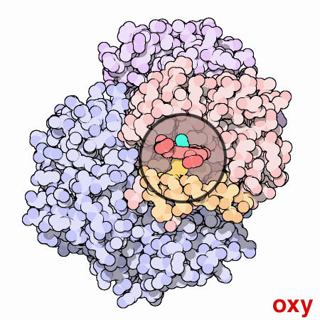

Figure 3. Animated GIF of oxy and deoxyhemoglobin can be viewed here: https://pdb101.rcsb.org/motm/41

30) Keep the tab for 1hbs open. Now, open a new tab, go the PDB main page and search for oxyhemoglobin (1hho)

31) Click on the “sequence” tab.

32) According to the “secondary structure” row, how many alpha helices and how many beta sheets are in chain B (beta subunit of globin); HINT: hover the mouse over each helix to see at which AA they begin and end.

33) Is the mutation site for sickle cell anemia located in an alpha helix in 1hho, an unstructured loop, or a beta sheet?

34) According to the “Binding Site HEM” row, how many amino acids bind to the heme molecule (abbreviated HEM)?
List them.

35) According to the “binding site OXY” row, how many amino acids bind to the oxygen molecule (abbreviated OXY)?
List them.

36) Return to the 3D view tab.

37) Set the sequence tab to view beta hemoglobin chain

38) Use the sequence panel to select histidine 92.

39) Toggle selection mode in the view port.

a) Enable select “Atom /Coarse Element” rather than “Chain” or “Residue”

b) Select the closest nitrogen to heme, and the iron on heme

c) Click “Measurements” in the control panel

d) Click “+Add”

i) Select “Distance (Top 2 Selection Items)

40) What is the distance between histidine 92 and heme for the beta chain of oxyhemoglobin? What is the shape of the heme molecule? Flat or puckered? What kind of noncovalent bond is measured here?

41) Capture an image depicting histidine 92, the heme molecule and the oxygen.
Make sure the bond length measurement is visible.

42) Repeat question 41) for deoxyhemoglobin and carbon monoxide hemoglobin:

PDB ID | description | H92-heme bond length (angstroms - Å) | Heme shape
2hhb | The structure of human deoxyhemoglobin
1hho | The structure of human oxyhemoglobin
2hco | The structure of human hemoglobin bound to carbon monoxide

43) What differences do you observe for bond length and heme shape?

44) Measure the bond length between oxygen and iron and the bond length between carbon monoxide and iron.
What are the lengths? Which is bound more strongly to the iron?

